Dear Parents
RE: PACK LUNCH POLICY
Please find attached a copy of the Meethill ELC Pack Lunch Policy. Hopefully you will find this policy helpful, and it will provide guidance on how to create healthy pack lunches for your child.
When providing a pack lunch for your child in the setting, there are a few important guidance points I would like to highlight for good practice:
- Please ensure your child’s pack lunch is CLEARLY labelled with your child’s name to save any confusion
- Please make sure you have placed a cold pack inside your child’s pack lunch – this will ensure that your child’s food is kept cool until lunch time. (We have very limited storage space in our fridge so can’t accommodate pack lunches)
- If you provide your child with grapes, PLEASE ensure these are cut into lengthways quarters as shown below, to avoid choking.

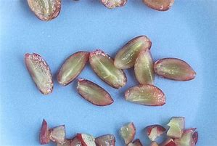

- Please read the Early Years Food Choking Hazards document attached to the Pack Lunch Policy for guidance on how to safely cut/prepare food for your child. This should help minimise choke risks.
- Please note that drinks are not required as we offer water and milk during snack and mealtimes.
- Please don’t put in lots and lots of food into your child’s pack lunch - it can be overwhelming for your child, and they may feel under pressure to eat it all
- Please note we will offer your child food if they seem interested in trying it – e.g. shortbread for pudding.
- Don’t worry if your child comes home with items left in their pack lunch box – staff are supervising them during lunch time and if they feel your child is not eating enough, this will be shared with you at pick up time.
If you have any further questions or queries relating to the Pack Lunch Policy, please do not hesitate to contact me at the setting.
Kind Regards
Jacqueline Turner
Early Years Senior Practitioner
Meethill ELC

